Hornet Pride 2015-2016
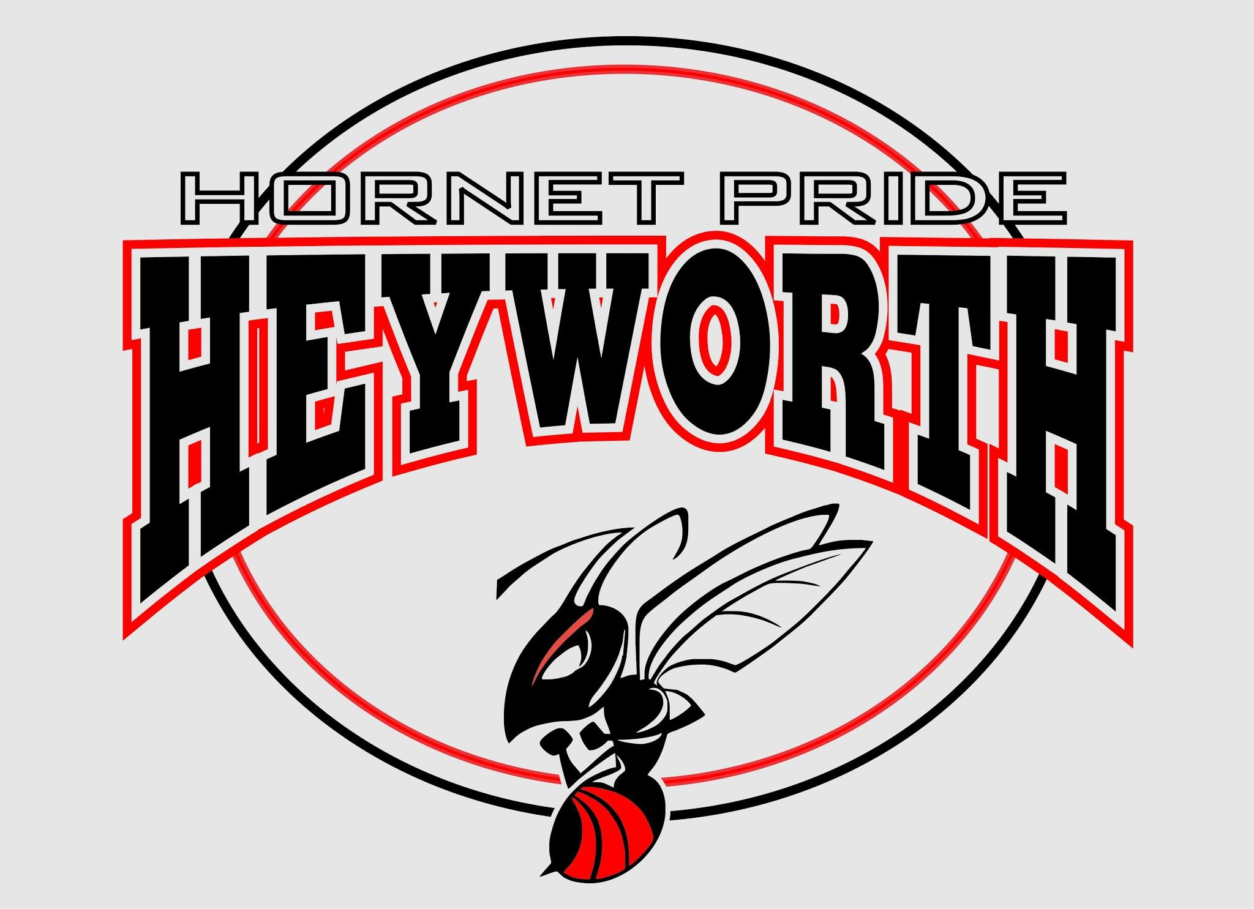

Shirt Small Medium Large XL *XXL/XXXL Total
Youth T-Shirt
$10 each
Youth Long-Sleeve T-Shirt
$12 each
Adult T-Shirt
$10 each
Adult V-Neck T-Shirt
$15 each
Adult Long-Sleeve T-Shirt
$15 each

*XXL and XXXL are an additional $3 per shirt

Total Number of Shirts: _______________________
Total Amount Due $ __________________________
Please make checks payable to HOPE

Name: ______________________________________________________
Student's Name:________________________ Teacher:_______________
Phone Number: ______________________ Email:___________________

